**DECIMAL TO OCTAL CONVERSION**

**AIM:**

To convert a decimal number into its octal equivalent using the 8085 microprocessor.

**ALGORITHM:**

1. Load the decimal number into a register (e.g., register B).
2. Initialize HL register pair to point to the memory location where octal digits will be stored.
3. Set up the divisor (8) in a register (e.g., register D).
4. Clear the remainder register (e.g., register C) and result register if needed.
5. Repeat the following steps until the number becomes zero
6. Copy the current value to accumulator.
   1. Call a subroutine to divide the number by 8.
   2. Store the remainder (octal digit) at the current memory location.
   3. Update the number with the quotient.
   4. Move HL to the next memory location (or previous, depending on digit order).

7.Terminate the program using HLT.

**Program :**

MVI B, 79H

LXI H, 2207H

MVI C, 00H

MVI D, 08H

LOOP: MOV A, B

CALL DIVIDE

MOV A, C

MOV M, A

DCX H

MOV A, B

CPI 00H

JNZ LOOP

HLT

DIVIDE: MVI B, 00H

MVI C, 00H

DIV_LOOP: CMP D

JC DONE_DIV

SUB D

INR B

JMP DIV_LOOP

DONE_DIV: MOV C, A

RET

**Output :**

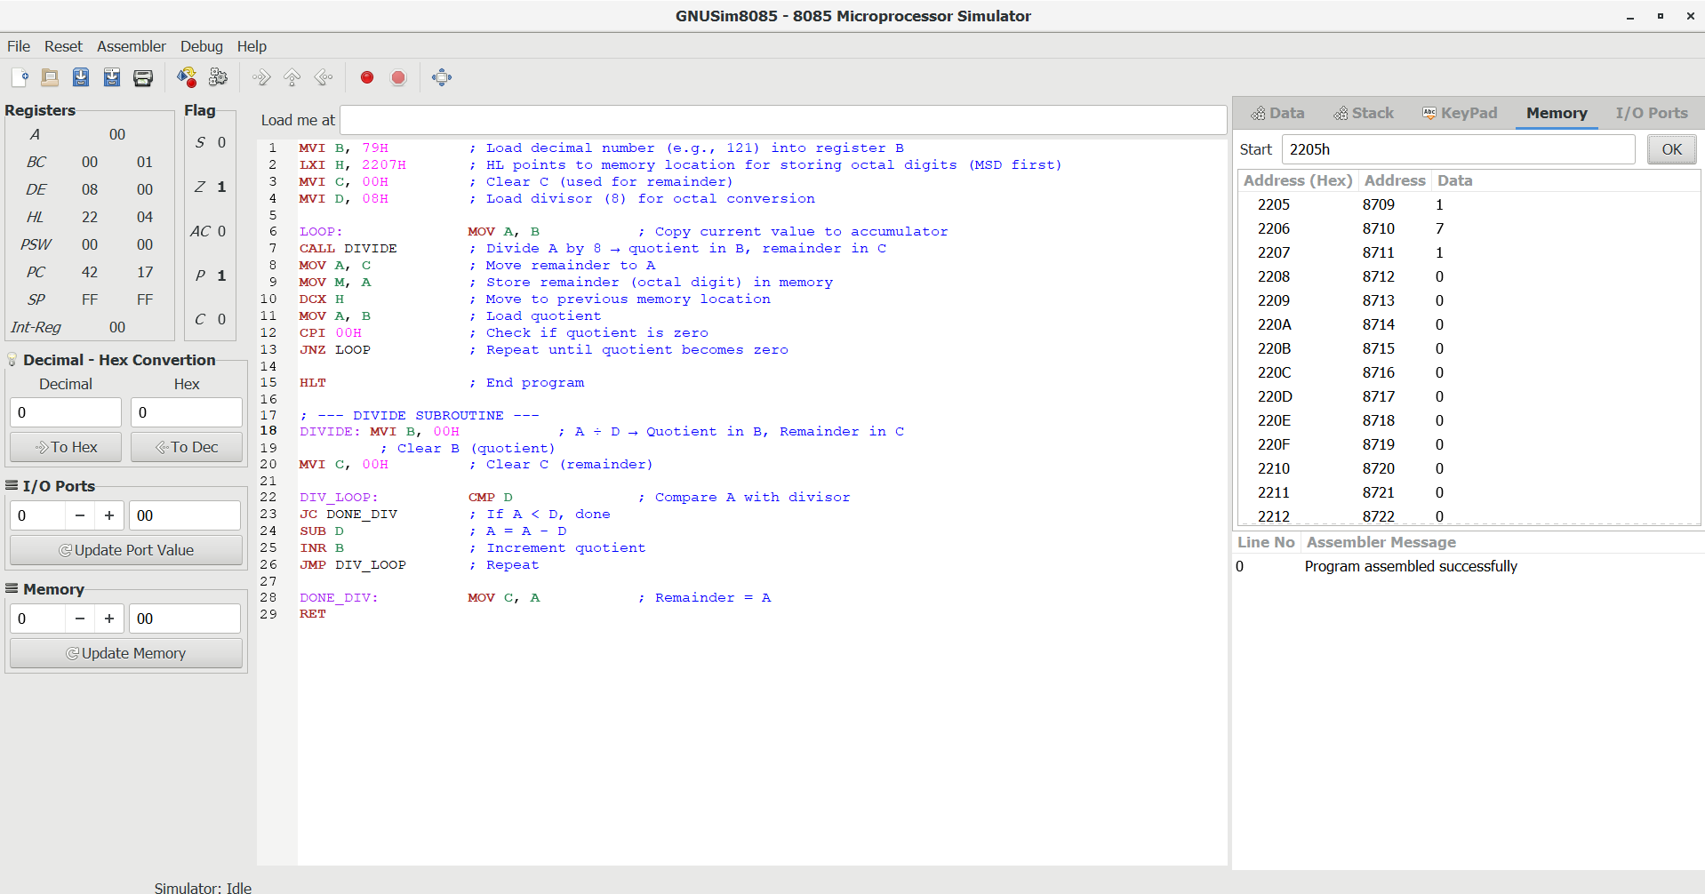

**RESULT:** Thus the program was executed successfully using 8085 processor simulator.